**Imperial College London**

**Department of Earth Science and Engineering**

**MSc Environmental Data Science and Machine Learning**

**Independent Research Project Final Report**

**Predicting Individual Physiological Responses to Pollution Using Transformer-Based Time-Series Models**

**Davide Baino**

**Email:** [**davide.baino24@imperial.ac.uk**](mailto:davide.baino24@imperial.ac.uk)

**GitHub: esemsc-db24**

**Supervisors:**

**Dr. Christopher Pain**

**Dr. Boyang Chen**

Table of Contents

1. Abstract 3

2 Problem Description 3

2.1 Rationale and Literature Review 3

2.2 Objectives 4

3 Dataset 4

4 Methodology 6

5 Timeline 8

1341 UNTIL METHODOLOGY

# Introduction

# Abstract

Air pollution remains a major global health and environmental concern, contributing to an estimated seven million deaths annually because of the combined effects of outdoor and household exposure ([WHO,](https://www.who.int/health-topics/air-pollution#tab=tab_2) 2025)[1]. While pollution levels are projected to decline, the ongoing impacts of climate change continue to pose serious risks. Simultaneously, advancements in wearable sensor technologies allow for the systematic collection of high-resolution physiological data over long periods of time (Roos & Slavich, 2023)[2].

This study aims to develop an identity map linking varying levels of air pollution to individual physiological responses. Such a framework will enable the prediction of health responses to pollution exposure, facilitating early warnings and personalised health recommendations. To achieve this, we propose a two-model approach: an initial general model to capture general population temporal trends, and a personalised one specialised on individual characteristics. Together, these models will enhance the precision of forecasting and contribute to more effective, data-driven health interventions when reacting to a polluted environment.

# 2. Problem Description

## 2.1 Rationale and Literature Review

Air pollution represents a critical challenge in the 21st century, with significant implications for human health. For example, He et al. [3] estimate that air pollution reduces average life expectancy by 1.8 years worldwide and up to 3 years in highly polluted regions of China. Cardiovascular and respiratory diseases as well as lung cancer are just some of the negative effects that the National Health System attributes to pollution (GovUK, *Health matters: Air pollution* 2018)[4].

Pollution occurs when substances from human, biological, or natural sources enter the atmosphere at concentrations beyond typical levels, posing short or long term risks (Bernasconi, Angelucci, & Aliverti, 2022)[5]. Pollutants are categorised as either primary, such as PM, CO, and NO, or secondary, formed through chemical reactions like O₃ and NO₂, often found far from their original sources. Even though this study focused primarily on criteria pollutants such as PM₁₀ and PM₂.₅, due to their severe health risks (Bernasconi, Angelucci, & Aliverti, 2022)[5], other pollutants like no, no2, o3, so2, co were examined for completeness.

Historically, air quality has been monitored using fixed-location stations, providing aggregated environmental data at a city or regional level. While useful for assessing general air quality trends, this approach presents two major limitations.

Firstly, fixed locations overlooks personal exposure to pollution. These static measurements fail to capture the highly personalised nature of pollution exposure, which varies significantly depending on a person’s location, mobility patterns, and daily activities (Hu et al., 2014)[6]. As a result, population-level estimates often obscure the true, specific impact of air pollution on human health (Hu et al., 2014)[6]. For instance, walking, jogging, or commuting through high-traffic areas can expose individuals to different pollution levels even within the same location (Hu et al., 2014)[6]. The same pollutant concentration may cause varying physiological responses across individuals, depending on factors such as health status, age, pre-existing respiratory conditions, and lifestyle (Hu et al., 2014)[6].   
Secondly, individuals inhalation rate drastically change the amount of pollutants an individual assumes over a fixed period of time. This is critical because including the amount of air and its relative pollution level helps us defining the actual pollution inhalation rate of patients rather only general pollution measures (Lu & Fang, 2014)[7].

Recent research has improved pollution forecasting, yet gaps remain in linking these predictions to health outcomes. For example, the Breath study employs a transformer-based model to predict NO₂ levels in India with high accuracy (Verma et al., 2024)[8]. However, it does not explore how these pollution fluctuations affect individual or population health, making it not useful for policymaking or preventative healthcare.

In contrast, Atseni et al. (2025)[9] developed a machine learning pipeline for short-term respiratory disease prediction. Their work underscores the importance of categorise individuals before modelling and demonstrates the effectiveness of traditional methods like Logistic Regression, Random Forest, and XGBoost. Nevertheless, it does not leverage modern deep learning techniques for time-series analysis, which could better capture temporal patterns in physiological data.

## 2.2 Objectives

The approach proposed in this study directly addresses the challenge outlined in the BEHRT initiative by integrating IoT-enabled wearable devices to support proactive and personalised health interventions Li, Y. et al. (2020)[10].

The value that this research is trying to add is not only to use wearable devices data to quantify the physiological response to pollution from individuals, but also to understand how much of the pollution surrounding the individual was practically inhaled with changing environmental conditions.

With this in mind, a transformer-based time series deep learning variational (GAN) encoder decoder architecture has been developed. The first objective is to leverage the transformer’s strength in modelling long-range temporal dependencies to identify population-level trends. Thereby enabling the construction of an identity map, a variational latent space, that relates pollution exposure to physiological responses. The second objective is to deliver real-time, individualised insights, alerting users to expect physiological changes when encountering similar pollution levels in the future.

3. Dataset

This study combines two datasets that complement each other, allowing us to examine how air pollution affects individual health responses.

**FIRST DATASET**

The first dataset is provided by the INHALE project (Imperial College London, *Inhale*)[11] and consists of data from 59 participants aged between 20 and 75 years, including 33 non-asthmatic and 26 asthmatic individuals. Each participant was equipped with wearable sensors that recorded information on air pollution exposure, respiratory health, and physical activity.

The INHALE dataset was the result of merging respiratory and pollution patients’ data at different time steps. The datasets, connected through a common patient id identifiers , were useful to understand how different levels of pollution, including primary and secondary would affect individuals. Breath rate averaged over minutes or its standard deviation were useful measures to understand patient’s reactivity to pollution.

The INHALE dataset temporal coverage was extremely limited. The data was collected during two distinct two-week periods in summer and winter, with non-continuous time steps. After some preprocessing , and specifically because of transformers time series needs, data was split into 1-hour long blocks where any shorter block was filtered out and not considered. This was useful to give the model enough data to understand how patterns would evolve in the long-run.

Dates and time fields also needed to be processed. Indeed, left as is, neural networks tend to treat each timestamp as a distinct category, focusing more on nearby ones while underestimating longer range relationships.

To fix this, we encoded time as cyclic signals. We extracted hour, day of week, and day of year, then mapped them onto sine and cosine functions so that times like 23:00 and 00:00 are treated as neighbours rather than distant values. This preserves natural cycles and helps the model learn daily, weekly, and seasonal patterns more effectively (Invidia Developer Forum*,*  2022)[12].

**SECOND DATASET**

The second dataset, coming from OpenWeather API, provides real-time air pollution levels, including key pollutants such as PM2.5, PM10 NO2 etc (*Current weather and forecast - openweathermap* 2025)[13]. Even though PM2.5 and PM10 were identified as the pollutants with the greatest consequences for individuals’ health, other pollutants like no, no2 , o3 and so2 were considered for a more complete approach, as per table below. Indeed, considering different pollutants is a good way to summarise not only inhalation rates when commuting, but also any primary or secondary agents inhaled when spending time indoor and outdoor (Jonidi Jafari et al., 2021)[14]

|  |  |
| --- | --- |
| **Pollutant** | **Sources** |
| **PM** | Transport (including exhaust fumes and tire & brake wear); combustion; industrial processes; construction & demolition; wind erosion |
| **NO₂** | Combustion processes (heating, power generation, and engines in vehicles & ships) |
| **SO₂** | Use of sulfur-containing fossil fuels for domestic heating, power generation, and vehicles |
| **CO** | Transport (especially petrol engines); combustion; industry |
| **O₃** | Photochemical reaction of NOₓ (from industry & vehicles) with VOCs (from automobiles, industry, solvents) |

*Figure 1: Pollutants by source – useful to understand impact on patients*

The Openweather dataset is geolocated using longitude and latitude coordinates, offering hourly pollution data at a spatial resolution of approximately 200 metres. When matched with the individual respiratory and pollution’s data coming from the Inhale dataset, it enables a spatially aware analysis of personal exposure to air pollution, allowing for the integration of environmental data with individual physiological responses. The hourly and 200-metre resolution is one of the key limitations of this study, because it does not help us capturing highly specific variations in pollution across different times of the day.

**MERGED DATASET**

The Inhale Dataset, coming from INHALE was therefore merged with the OpenWeather dataset based on longitude, latitude and timestamp. This was key, since it gives us a map of how individuals moved across London, including different levels of indoor and outdoor pollution as well as their physiological responses to it.

Pollution levels together with individuals’ physiological responses from patients across time and inhalation rates were the backbones of our dataset resulting in a highly accurate and specialised model.

# 4. Methodology

1. EDA CORRELATION FEATURES

After merging the dataset and deploying data preprocessing techniques, some exploratory data analysis was implemented so that the transformer model could later be trained.

Outliers removal was an essential first step. Given the data collection process and the research objectives, outliers were handled manually rather than with standard Inter Quartile Range methods. This choice reflects the importance of retaining real spikes, f.i. a sudden increase in breath rate that may indicate reactions to pollution. At the same time, implausible values were excluded, for example temperatures of 56 °C in March or pollution levels high enough to be immediately lethal. These unrealistic records were removed from the dataset.

After removing outliers, the data was normalised. Standard normalisation was necessary because the features had very different scales, and without adjustment, variables with larger magnitudes would have disproportionately influenced the model.

In addition, 12 patients were completely excluded. This is because their breath rate average feature was missing around 30/40% of total value, leading to imputation as the only viable option.

After cleaning and processing the data, a correlation heatmap, as shown in figure 2, was generated to examine relationships between features. As expected, breath rate and physical activity features have some correlation, greater levels of physical activity leads to more frequent breaths and so greater breathing rate. Strong correlations also appeared among pollution measures, consistent with the fact that polluted environments typically contain multiple pollutants. There is no evident correlation between physiological measures and pollution measures from the correlation map.

A Pearson correlation heatmap, as the one below, is mainly used to define linear relationships, while the relationship between patients’ physiological data and pollution is non-linear. Only by looking at multi-features over different time steps we could identify any relationship between the two.

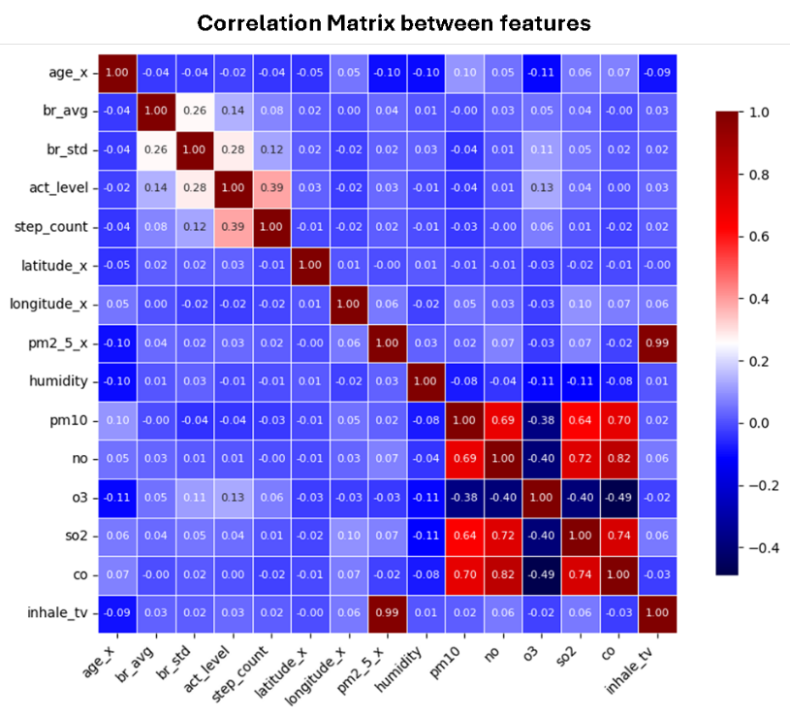

*Figure 2: Correlation Matrix between different features showing strong correlation between pollution measures and between physiological measures*

2. Data Loading – Sliding Window Dataset

We randomly took 30 of the 44 patients for training and 13 for testing. This is key because the model needs both healthy and asthmatic patients. Keeping the original sequence order would have biased the results.

A custom data loader was defined and applied to both training and test data. The first step was to determine how many windows to create using the formula:

**Number of windows = (number of samples – window size – forecast steps) // step**

This shows that the number of windows depends on the dataset size, reduced by the number of past steps and future steps, then adjusted by the step size to optionally skip rows for memory efficiency. Each window was then split into an input and a target. The input represents the historical data used for training while the target is the future data the model must predict. With this setup, the model iteratively learns by processing each input block and predicting its corresponding target.

3. Models

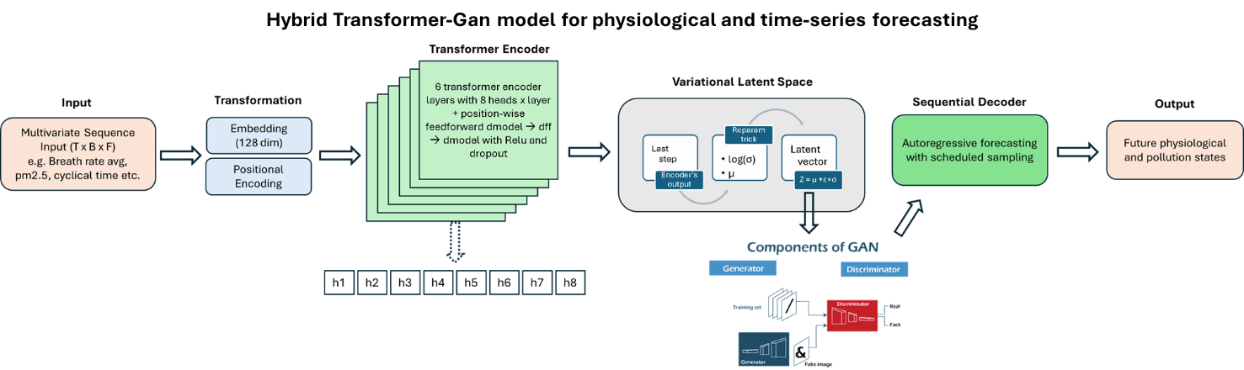

*Figure 3: Transformer Vae Gan* *(Thatipalli, 2023)[15] Encoder Decoder design structure*

**3.1. Customer transformer encoder**

The model takes in multivariate sequences of physiological and environmental data, such as breathing rate, activity, and pollution measures across different time steps. The input is structured as a 3d tensor of sequence length, batch size and number of input features. Each time step is embedded into a higher-dimensional vector (128 dimensions) and with added sinusoidal positional encodings, so that temporal order between different time steps is preserved.

Once embedded and positionally encoded, the sequence is then passed through a stack of six transformer encoder layers.

Each encoder layer has two main parts: multi-head self-attention and a feedforward network. Self-attention lets each time step the whole sequence, capturing both immediate and delayed responses (Casolaro et al., 2023)[16] . This is crucial for physiological data, where reactions to pollution may be fast or gradual. Our model uses eight attention heads, with some attending to short-term fluctuations and others to longer-term patterns, reflecting how individuals respond to both recent and past exposures(Vaswani et al., 2017)[17].

After self-attention, the outputs pass through a two-layer feedforward network with a ReLU activation in between. The first layer expands the representation from the embedding size (d_model) to a larger hidden size (dim_feedforward), giving the model more capacity to learn. ReLU adds non-linearity, and dropout reduces overfitting by randomly dropping activations. The second layer then projects the representation back to the original embedding size.

**3.2 Variational Latent Space**

After the input sequence passes through the Transformer encoders, the final hidden state is taken as a compact summary of the sequence (dimension = d_model). This state is projected into two vectors: a mean (μ) and a log-variance (log(σ²)), which together define a multivariate Gaussian distribution. Instead of mapping inputs to a single point, we use a variational approach that samples from this distribution(Mao et al., 2020)[18]. The standard deviation is computed as:

σ = exp(0.5 × log(σ²))

To keep the sampling step differentiable, we apply the reparameterisation trick:

s = μ + ε × σ , where ε ~ N(0, I)

The sampled latent vector s (typically of lower dimension f.i. 64) acts as a bottleneck representation, keeping the key temporal information needed for forecasting. Combining this variational latent space with the transformer encoder allows the model to capture both temporal dependencies and uncertainty, making it powerful for physiological time-series prediction.

**3.3 Training**

The model is trained with an adversarial autoencoding framework designed for time-series forecasting. Training runs in two phases.

In the first phase, a discriminator learns to distinguish between latent vectors sampled from a standard normal distribution (s_real) and those generated by the encoder (s_fake). This pushes the encoder to align its latent space with the Gaussian prior.

In the second phase, the encoder–decoder is trained to forecast the next block of the sequence. The loss is measured as the mean squared error (MSE) between the predicted and actual values. Forecasting is done autoregressively across multiple steps. To improve robustness, scheduled sampling is applied with the model gradually shifting from using true inputs (teacher forcing) to using its own predictions during training.

After each forward pass, a new latent vector is sampled from the encoder’s distribution, and the encoder is also trained to fool the discriminator. This adversarial loss is weighted and added to the reconstruction loss. A learning-rate scheduler lowers the rate when validation loss plateaus, and early stopping prevents overfitting.

Together, these steps combine accurate forecasting with latent space regularisation, improving both predictive performance and generalisation.

**4. Results and discussions**

We start discussing model results by focusing on general trends from the 43 patients trained model. We begin by explaining why forecasting was the main focus rather than reconstructing the input and we will then analyse clustered reactions to pollution. We will delve deeper to discover whether asthmatic individuals show stronger or weaker responses than healthy ones. Pollution levels will then be perturbed to observe changes in physiological measures.

After discussing general model results, we focused on generalisation by fine-tuning the general model on data from one unseen individual. Finally, we propose a threshold-based alert system that forecasts an individual’s physiological responses to pollution and triggers warnings when critical thresholds are expected to exceed.

**4.1 Prediction**

Using a multimodal time series model combining pollution concentrations, inhalation rate, and physiological signals, we predicted next-hour physiological and pollution measures aggregated across all subjects.

As shown in figure 3, the model is able to track closely both physiological measures such as breath average and pollution levels, with large spikes being the hardest to capture. Two design choices are key to this performance. The former is the ability of transformers to capture temporal dependencies, where past inputs affect both present and future timesteps. The latter comes from adversarial training, where generator and discriminator are working together to make the predictions as realistic as possible.

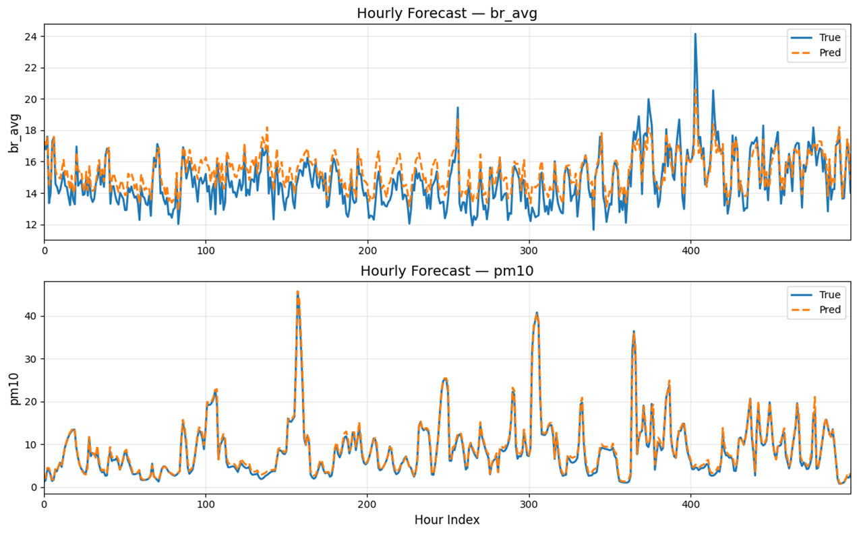

*Figure 3: Prediction of breath rate average (br_avg) and pollution (pm10) on a hourly basis aggregated to all patients*

Also, we decided to focus on forecasting rather than reconstructing inputs to anticipate how an individual’s physiology responds to pollution. The learned latent space captures person-specific dynamics, making forecasts valuable to provide individuals with clear insights and actionable support.

* 1. **Cluster reaction to pollution (What you can’t see)**

After showing that next-step forecasting was feasible and accurate, we analysed how patients reacted to pollution and whether subgroups had stronger or weaker responses. For each patient, sliding windows were passed through the model to extract latent vectors (z), which were then averaged to produce a single embedding per individual. These embeddings were clustered using K-Means to identify groups with similar response patterns.

Most individuals clustered closely together, reflecting the Gaussian distribution learned by the adversarial model, while a few formed distinct groups, suggesting different than average physiological response to pollution.A graph with colored circles

*Figure 4: K-cluster for all patients in seven distinct groups including healthy and asthmatic individuals*

For a better understanding of group-specific responses to pollution, we examined the distributions and medians of pollution and physiological measures across the seven clusters.

Starting with cluster 3, we can see how it was characterised by the highest PM₂.₅ and PM₁₀ levels and shows one of the largest increases in average breathing rate. However, it does not result in the strongest one. This is likely because activity levels in this group are relatively low. Cluster 4 illustrates this relationship really well: despite slightly lower PM₂.₅/PM₁₀, higher activity levels are associated with the strongest breathing-rate response. In contrast, Cluster 0 has modest PM₂.₅ but elevated O₃ and SO₂ relative to other clusters, consistent with vehicles and indoor pollution influences; individuals in this group appear more affected by these pollutant mixtures.

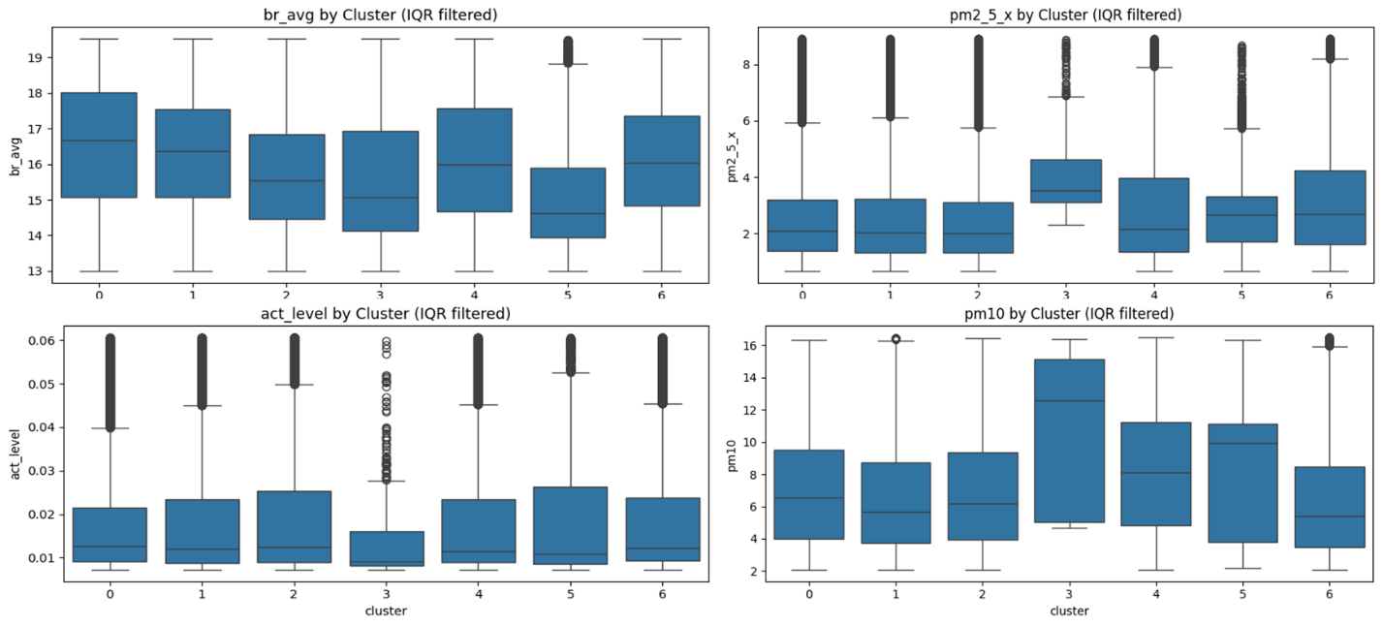

*Figure 5: Distribution of breath rate average, pm2.5, activity level and pm10 by seven clusters*

Besides clustering individuals based on their response to pollutants, we also decided to analyse whether healthier individuals respond to pollution any differently than asthmatic ones. We divided our dataset in two categories, where asthmatic individuals were 19 while healthy ones were 24. In addition, the healthy patients group have inherently more data which involves the model being able to forecast, reconstruct and understand healthy individuals better.

Although the literature suggests that asthmatic individuals tend to react more strongly to pollution than healthy ones (Kim et al., 2013)[19], our study does not show that. This was expected for a few different reasons. Healthy individuals were exposed to higher levels of pm2.5 than asthmatic. This, together with higher activity levels induced a more intense level of inhalation rate across time for healthy patients.

In practice, greater pollution exposure, higher activity levels, driven by healthy individuals commuting more than asthmatics, resulted in a more critical breathing-rate response among healthy participants, as illustrated in the figure below.

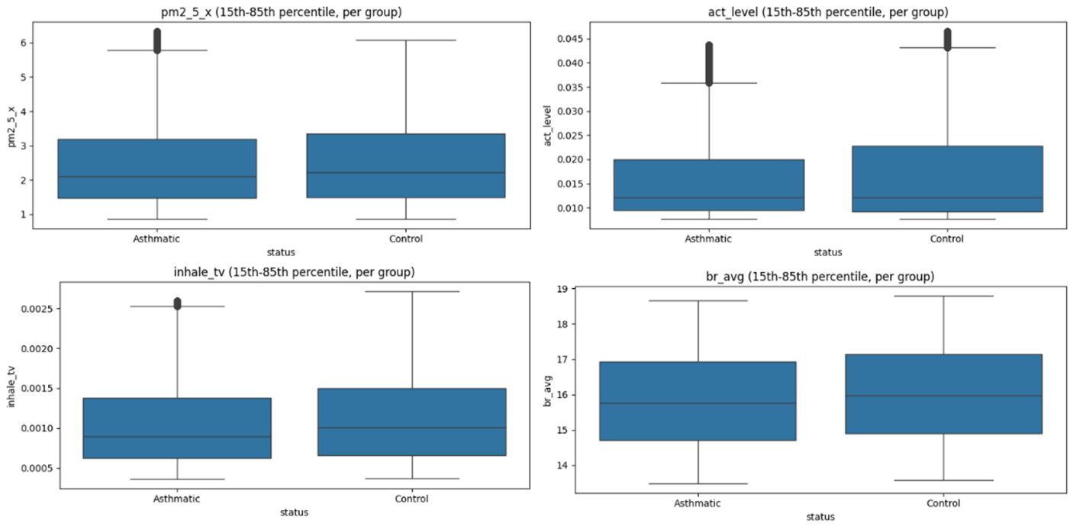

*Figure 6: Distribution of pm2.5, activity, inhalation rate and breath rate for healthy (control) vs asthmatic patients*

* 1. **Perturbation - greater level of pollution**

After comparing healthy and asthmatic groups, we assessed cluster-level reactivity to pollution using a perturbation experiment. Pollution inputs were artificially scaled (1×, 2×, 4×, 6×) while all other variables—activity, temperature, humidity, inhalation volume, and time encodings—remained fixed. The adjusted data was windowed, normalised with the original scaler, and passed through the model to forecast one step ahead. For each scenario, we examined predicted physiological outcomes (e.g., average breathing rate) across clusters. Results were pooled within clusters and visualised with boxplots, trimming the 10–90% range to reduce the influence of extreme values.

From the picture below, we noticed that greater levels of pollution leads to higher volatility within breathing rate, meaning more erratic unstable breathing. This phenomenon is working for all the different clusters. When looking though at breath rate average per cluster, we can see how specific clusters, such as 1 and 3 are more reactive to pollution while the other clusters do not react as strongly.

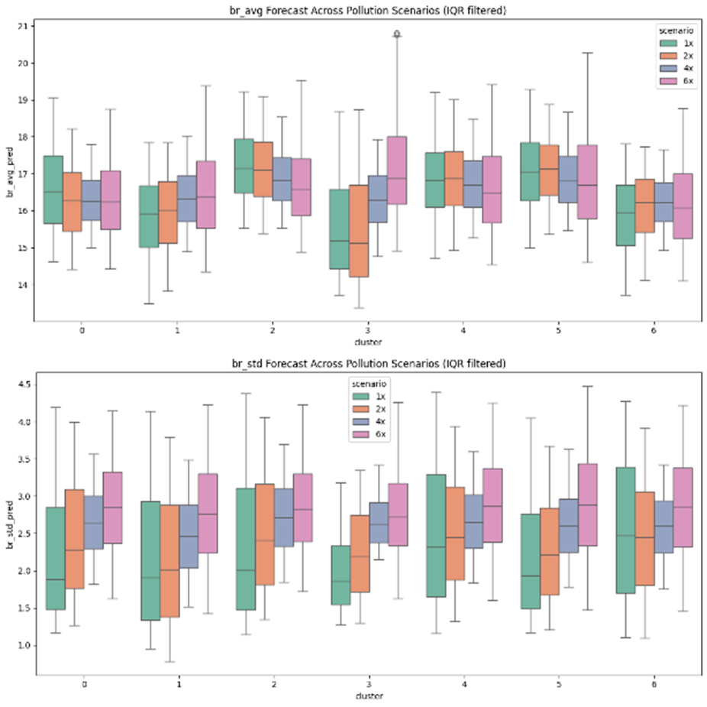

*Figure 8: Perturbation of pollution measures by clusters (from 1 baseline to 6 time the baseline)*

As shown above, comparing the baseline scenario, with unchanged pollutants inputs with the most extreme case (x6) reveals distinct cluster-specific responses. Clusters 1, 3, and 6 show the strongest reactivity, with breath rate rising by up to 11%. In contrast, Clusters 0, 2, 4, and 5 display only mild changes in average breath rate but reflect more erratic standard deviations, indicating spikier breathing patterns.

* 1. **Focusing on Individual only**

After forecasting future steps for all individuals and identifying which clusters were more or less reactive to pollution, we tested whether the general model could generalise to unseen individuals.

As shown in figure 9, the model successfully predicted hourly physiological responses for new patients. This shows that the model captured general trends from the training patients while also adapting to new features, patterns, and edge cases in unseen data. Proving its ability to generalise to entirely new dynamics.

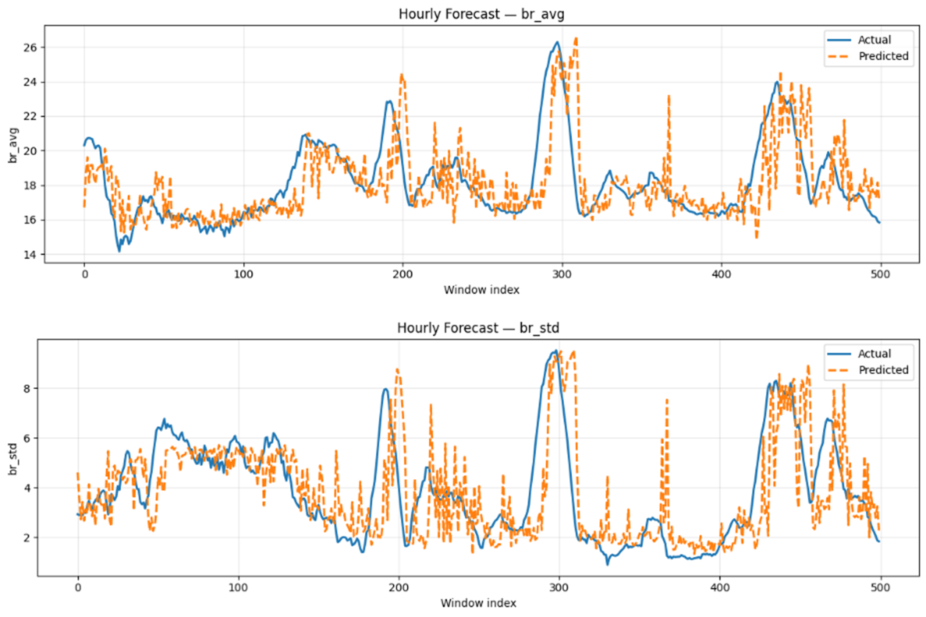

*Figure 9: Forecast of unseen data hourly for both breath rate average and standard deviation*

**4.5 Threshold -Based alert risk detection system**

The system is built to detect periods of unusual physiological change linked to pollution exposure. It does this by first establishing a baseline profile for each individual, then tracking deviations from that baseline as new data arrives, and finally flagging high-risk events when both pollution and physiological deviations are unusually high.

The baseline is created by passing all sliding windows coming from the validation dataset through the model and extracting the first forecasted timestep per feature. These forecasts are inverse transformed and averaged to produce a reference vector representing the individual’s expected physiological state under normal conditions.

New forecasts are then compared to this baseline, generating a deviation score that quantifies how far the physiology has shifted from normal behaviour. Repeating this process creates a continuous deviation series alongside pollution values at each timestep.

Risk was defined using percentile thresholds. Pollution values above the 75th percentile were treated as high exposure, while those below the 25th percentile were treated as low. Since these thresholds are calculated from each individual’s own data, they are customised to different patients baseline vector, adapting automatically to different individuals.

An alert is then triggered only when both conditions are met: pollution exceeds its 75th percentile and the physiological deviation also exceeds its own threshold. These events, highlighted as red dots in the final visualisation, indicate moments when environmental stress and physiological stress coincide. Indeed, because the alert system gets triggered only when physiological deviation and pollution measure are both high, false alarms are skipped. Situation where only pollution is high but there is no reaction to it from the chosen patient, or physiological measures deviation is abnormal but not driven by pollution are not considered because not useful for our study. As we can see below in figure 10, red markers highlight critical events, giving the system the option to be an early-warning tool.

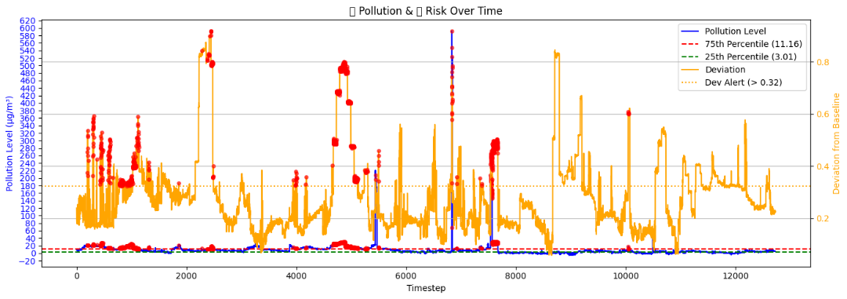

*Figure 10: Hourly Threshold alerting system with pollution level in blue, deviation from standard in yellow and red points potential alerts.*

**5. Limitations**

Even though the overall number of patients included in the study was representative enough, the imbalance between healthy and asthmatic makes it skewed. Healthy individuals contributed with more data, which means the model is better at capturing their responses compared to asthmatic individuals.

The entire dataset was collected in London. This spatial restriction is a key limitation because it weakens generalisability. Pollutants, weather conditions and commuting patterns varies across different regions, so the model won’t generalise well with other cities or countries.

The physiological measures were also limited. Breath rate and its evolution over time is not enough to quantify the full effects of pollution on individuals. Additional signals, such as heart rate, stress levels would provide a more complete map of how individuals react to pollution in the short and long-term.

The OpenWeather dataset also brings some additional limitations. Its hourly temporal resolution, preventing minute by minute analysis, and its 200metres spatial resolution is not able to capture micro-environmental variations (roadside vs indoor exposure). These limitations are especially relevant for commuting or other short-term activities where exposure changes quickly.

Finally, the model architecture also has some limitations. The Transformer–VAE–GAN architecture, while powerful in capturing nonlinear temporal dependencies, operates as a black box. Its internal representations make it difficult to attribute predictions to specific pollutants or physiological drivers. The challenge of interpretability reduces the model’s suitability for clinical applications.

**6. CONCLUSION**

After conducting exploratory data analysis on the data, implementing data preprocessing techniques, a clean set of data was fed to the model. Then, a Transformer Vae Gan was trained with the aim to forecast next time steps, including both physiological and pollution measures.

After the model has been developed and results have been comprehensively analysed, we clearly identified that the model is precise enough to forecast next steps both in terms of general trends but also fine-tuned to unseen individuals. In addition, after applying a k-clustering technique to individuals’ latent space, we can see how different clusters reactive differently to similar levels of pollutions. With some clusters being more reactive to pollution, with spikes reaching 11% (when pollution is increased 6 times) while other clusters having a mild reaction to perturbation.

In addition, a threshold alert system was developed to operationalise the model. Indeed, being able to alert individuals on how they will physically react when experiencing similar pollution levels could be a great aid especially for those clusters that are very sensitive to pollution. Another activity, or a different way to commute could be suggested to reduce overall pollution exposure and inhalation rates.

# 6. References

1. World Health Organisation Overview (2025) Available at: <https://www.who.int/health-topics/air-pollution#tab=tab_1> (09 June 2025).
2. Roos, L.G. and Slavich, G.M. (2023) ‘Wearable Technologies for health research: Opportunities, limitations, and practical and conceptual considerations’, Brain, Behavior, and Immunity, 113, pp. 444–452. doi:10.1016/j.bbi.2023.08.008.
3. He, Q. and Ji, X. (James) (2021) ‘The labor productivity consequences of exposure to particulate matters: Evidence from a Chinese National Panel Survey’, International Journal of Environmental Research and Public Health, 18(23), p. 12859. doi:10.3390/ijerph182312859.
4. Health matters: Air pollution (2018) GOV.UK. Available at: https://www.gov.uk/government/publications/health-matters-air-pollution/health-matters-air-pollution (Accessed: 14 August 2025).
5. Bernasconi, S., Angelucci, A. and Aliverti, A. (2022) ‘A scoping review on wearable devices for environmental monitoring and their application for Health and Wellness’, Sensors, 22(16), p. 5994. doi:10.3390/s22165994.
6. Hu, K. et al. (2014) ‘Personalising pollution exposure estimates using wearable activity sensors’, 2014 IEEE Ninth International Conference on Intelligent Sensors, Sensor Networks and Information Processing (ISSNIP), pp. 1–6. doi:10.1109/issnip.2014.6827617.
7. Lu, Y. and Fang, T. (2014) ‘Examining personal air pollution exposure, intake, and Health Danger Sone using time geography and 3D geovisualisation’, ISPRS International Journal of Geo-Information, 4(1), pp. 32–46. doi:10.3390/ijgi4010032.
8. Verma, A., Ranga, V. and Vishwakarma, D.K. (2024) ‘Breath-net: A novel deep learning framework for no2 prediction using bi-directional encoder with Transformer’, Environmental Monitoring and Assessment, 196(4). doi:10.1007/s10661-024-12455-y.
9. Atseni, M. et al. (2025) ‘A machine learning framework for short-term prediction of chronic obstructive pulmonary disease exacerbations using personal air quality monitors and lifestyle data’, Scientific Reports, 15(1). doi:10.1038/s41598-024-85089-2.
10. Li, Y. et al. (2020) ‘Behrt: Transformer for Electronic Health Records’, Scientific Reports, 10(1). doi:10.1038/s41598-020-62922-y.
11. *Inhale* (2024) *Imperial College London*. Available at: https://www.imperial.ac.uk/earth-science/research/research-projects/inhale/ (Accessed: 14 August 2025).
12. Three approaches to encoding time information as features for ML Models (2022) NVIDIA Technical Blog. Available at: https://developer.nvidia.com/blog/three-approaches-to-encoding-time-information-as-features-for-ml-models/ (Accessed: 19 August 2025).
13. (2025) Current weather and forecast - openweathermap. Available at: https://openweathermap.org/ (Accessed: 14 August 2025).
14. Jonidi Jafari, A., Charkhloo, E. and Pasalari, H. (2021) ‘Urban Air Pollution Control Policies and strategies: A systematic review’, Journal of Environmental Health Science and Engineering, 19(2), pp. 1911–1940. doi:10.1007/s40201-021-007444.
15. Thatipalli, A. (2023) Generative Adversarial Networks (Gans): A simple explanation, Medium. Available at: https://ai.plainenglish.io/generative-adversarial-networks-gans-a-simple-explanation-6860afda181f (Accessed: 19 August 2025).
16. Casolaro, A. *et al.* (2023) ‘Deep learning for time series forecasting: Advances and open problems’, *Information*, 14(11), p. 598. doi:10.3390/info14110598.
17. Vaswani, A., Shaseer, N., Parmar, N., Usskoreit, J., Jones, L., Gomes, A.N., Kaiser, Ł. & Polosukhin, I., 2017. Attention is all you need. In Advances in Neural Information Processing Systems (NIPS 2017).
18. Mao, X. and Li, Q. (2020) ‘Generative Adversarial Networks (gans)’, Generative Adversarial Networks for Image Generation, pp. 1–7. doi:10.1007/978-981-33-6048-8_1.
19. Kim, K.-H., Jahan, S.A. and Kabir, E. (2013) ‘A review on human health perspective of air pollution with respect to allergies and asthma’, Environment International, 59, pp. 41–52. doi:10.1016/j.envint.2013.05.007.